QUESTION 1

Write a query to display the employees whose firstname starts with 'Y' and ends with 'n' from employees table

select * from employees where first_name like "Y%n";

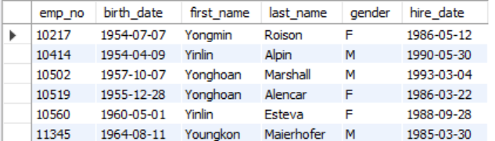

QUESTION 2

Write a query to display the emp_no and salary increased by 30% from salaries table.

select emp_no, salary*1.3 as increased_salary from salaries;

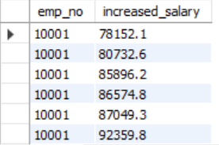

QUESTION 3

Write a query to display unique titles from titles table.

select distinct title from titles;

